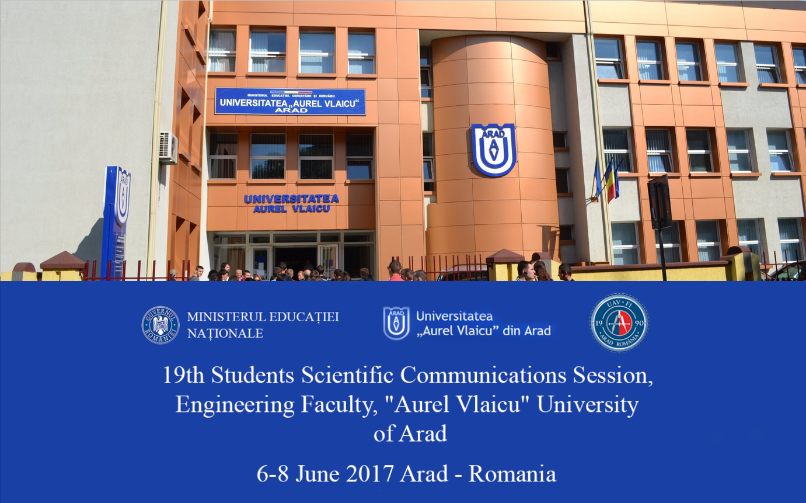

PROGRAM

ARAD,
6-8 June 2017
The International Students Scientific Communications Session of the Engineering Faculty of Aurel Vlaicu University from Arad is at its 19th edition.
As always, the main purpose is to offer the students the opportunity to demonstrate their knowledge and skills in different branches of engineering: automate control, automobiles, mechanics or IT, through original scientific papers resulting out of innovative and creative research.
This session of scientific communication is helping undergraduate, master or doctoral students from different universities from Romania or abroad to exchange opinions, knowledge, to link forthcoming collaborations, to make friends and get tips from the best in field. The participation diplomas and the prizes for the best works that will be awarded to the participants will be an added bonus in their resume. The participation and the competition is challenging and beneficial for the professional evolution of the students.

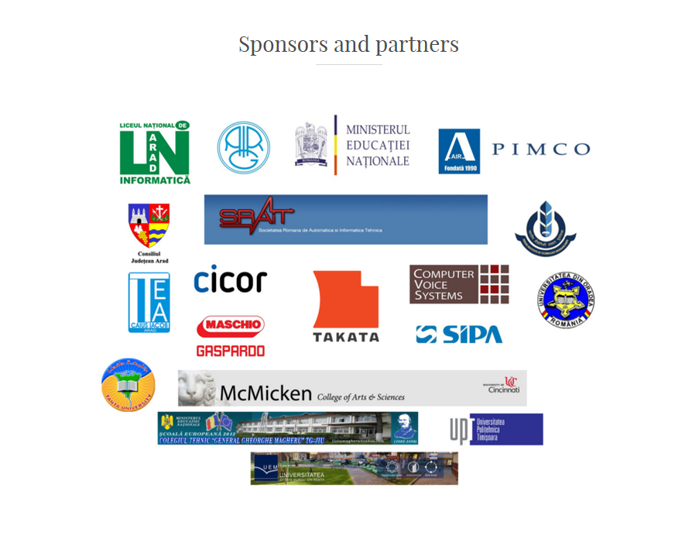

Committees

Advisory Committee:
- Rector: Ramona Lile
- Vice-Rector: Codruta Stoica
- Vice-Rector: Popa Alexandru
- Vice-Rector: Teodor Cilan
- Dean - Faculty of Engineering: Dan Glavan
- Vice-Dean: Doina Mortoiu
- Vice-Dean: Adina Bucevschi
- Director of department: Gheorghe Sima

Scientific Committee:
- Valeriu Beiu (Romania)
- Michio Sugeno (Japonia)
- Lakhmi C. Jain (Australia)
- Anca Ralescu (USA)
- Dan Ralescu (USA)
- Bernadette Bouchon-Meunier (France)
- Salil Bose (USA)
- Ioan Dzitac (Romania)
- Octavian Prostean (Romania)
- Gheorghe Capatana (Republic of Moldova)
- Simona Dzitac (Romania)
- Gelu Ovidiu Tirian (Romania)
- Mohamed Salim Bouhlel (Tunisi)
- Rajeeb Dey (India)
- Seshadhri Srinivasan (India)
- Muhammad Waseem Ashraf (Pakistan)
- Ankur Gupta (India)
- Nilanjan Dey (India)
- Amira Ashour (Egypt)
- Fuqian Shi (China)
- Bhuvan Modi (USA)
- Muhammad Arif (Pakistan)
- Mohit Mittal (India)
- Barla Eva (Romania)
- Rob Raluca (Romania)
- Cornelia Victoria Anghel Drugarin (Romania)
- Roxana Beiu (Romania)
- Clara Rohatinovici (Romania)
- Kristijan Cincar (Republic of Serbia)
- Marius Buzera (Romania)
- Maria Petcut (Romania)
- Maria Muresan (Romania)
- Florina Pasculescu (Romania)
- Carmen Rus (Romania)

Organizing Committee:
1. Electrical Engineering and Informatics section:
- Marius M. Balas
- Valentina E. Balas
- Virgil F. Duma
- Valentin Muller
- Corina Mnerie
- Ioan Koles
- Cornel Barna
- Nicolae Popescu-Bodorin;
- Daniel Dragu
- Noemi Clara Rohatinovici
2. Mechanics section:
- Ioan Radu
- Iosif Kaposta
- Liviu Sevastian Bocii
- Adriana Motica
- Gheorghe Hutiu
- Dorin Demian
- Lucian Gal
- Aurelia Tanasoiu
- Laurentiu Jitaru
- Mihai Sirb
- Stela Muncut
- Sorin Jurca
- Radu Negrila
- Theoharis Babanatsas
- Andrei Komjaty
- Lavinia Culda
- Ioan Pernevan
3. Textiles section:
- Ionel Barbu
- Cecilia Sirghie
- Monica Szabo
- Magdalena Fogorasi
- Monica Pustianu
- Erzsebet Airinei

PROGRAM

6 June:
- Reception and accommodation of external participants
- 20:00 - Dinner for external participants

7 June:
- 07:00-09:00 Breakfast for external participants
- 09:00-10:00 Registration of participants
- 10:00-10:15 Opening Ceremony
- 10:00-10:45 Plenary Conference - Prof. Valeriu Beiu
- 10:45-11:45 Presentation of partner companies
- 11:45-12:45 Skype Session I
- 12:45-13:15 Visit to the Institute for Research, Development, Innovation in Technical and Natural Sciences in UAV
- 13:15-14:00 Lunch
- 14:00-16:00 Parallel Sessions and Skype Session II
- 16:00-18:00 Visit Arad City
- 20:00 Banquet and prize award for best papers

8 June:
- 07:00-09:00 Breakfast for external participants
- Departure of participants

Section: Energetic and Renewable Energies

Evaluation Commission: President: Conf.dr.ing. Valentin Muller
Members: Conf.dr.ing. Simona Dzitac
Asist.Prof. drd. Marius Lolea
Secretary: Ing. Petru Hudacov

- Ahmad Khalifeh, DziţacDomnica-Ioana , OPERATION AND PLANNING OF ENERGY SYSTEMS AND SMART METERS APPLICATION IN SMART GRIDS, (coord. conf. univ. dr. ing. Dzițac Simona, ing. Mortan Sorin), University of Oradea, Struer Stats gymnasium – Denmark, SC Ciucleatex SRL Beiuş

- DziţacDomnica-Ioana, Ahmad Khalifeh, Şandro Cristian, CozmaHoraţiu , EFFECTS OF HIGH FREQUENCY ELECTROMAGNETICAL FIELD ON BIOLOGICAL SYSTEMS, (coord. asis. drd. ing. Lolea Marius, conf. univ. dr. ing. Dzițac Simona), Struer Stats gymnasium - Denmark, University of Oradea

- Filip Iuliu Florian, Tocai Dorina,METHODS DEDICATED TO THE OPTIMIZATION OF THE LEVEL OF REDUNDANCY,(coord. conf. univ. dr. ing. Dzițac Simona, şef lucr. dr. ing. Barla Eva), University of Oradea

- Ahmad Khalifeh, Dziţac Domnica-Ioana,Vălean Mărioara, PRACTICAL ASSESSMENT AND ANALISYS OF THE EXPOSURE LEVEL IN ELECTRICOMAGNETIC FIELD OF HUMAN BODY, (coord.asis. drd. ing. Lolea Marius, conf. univ. dr. ing. Dzițac Simona), University of Oradea, Struer Stats gymnasium – Denmark

- drd.ing. Ias Gheorghe, drd. ing. Lolea Marius, POSSIBLE INCIDENTS AND RISKS WHICH AFFECTING THE CONNECTION OF THE EOLIEN ENERGY SYSTEMS AND THEIR MINIMIZATION TECHNIQUES, (coord. prof. univ.dr.ing. Felea Ioan, conf. univ. dr. ing. Dzițac Simona), University of Oradea

- drd. ing. Lolea Marius, drd.ing. Ias Gheorghe, INCERTITUDES AND APPROXIMATIONS IN THE APPREACIATION OF EXPOSURE EFFECTS IN ELECTROMAGNETIC FIELD,(coord. prof. univ.dr.ing. Felea Ioan, conf. univ. dr. ing. Dzițac Simona), University of Oradea

- Ing. PetruHudacov, Cornel Mot, Valentin Timis, INTELLIGENT HOUSE CONTROL, (coord. Prof.univ.dr.ing. Valentina Emilia Bălaș), Aurel Vlaicu University of Arad

- Vesa Bogdan Raul, Mot Andrei, ECO HOUSE OF THE FUTURE, (coord. Prof.univ.dr.ing. Valentina Emilia Bălaș), Aurel Vlaicu University of Arad

- Rus Roland Eduard, Laza Dana Anamaria, SCADA SYSTEM FOR RENEWABLE ENERGIES, (coord. Prof.univ.dr.ing. Valentina Emilia Bălaș), Aurel Vlaicu University of Arad

Section: Informatics
Evaluation Commission: President: S.l..dr.ing. Corina Mnerie
Member: Dr. psychologist Dana Balas Timar
Secretary: Drd.Ing. Noemi Clara Rohatinovici

- Emanuiel Bunceanu, On Alin, Birău Laura, ETHICAL HACKING: SECURITY FOR FUTURE, (coord. S.l.dr.ing. Cornelia Victoria Anghel Drugărin), Eftimie Murgu University from Resita

- Dr. psiholog Dana Balas Timar, INTERVIEW SCORING AND DECISION MAKING WITH FUZZY LOGIC - TECHNIQUE FOR SCORING COMPETENCY BASED BEHAVIOURAL INTERVIEWS: A FUZZY APPROACH, (coord. Prof. dr. ing. Valentina Emilia Balas), Aurel Vlaicu University of Arad

- Drd.ing. Rohatinovici Noemi, EVALUAREA RETELELOR COMPLEXE, (coord. Prof. dr. ing. Valentina Emilia Balas), Politehnica University Timisoara, Aurel Vlaicu University of Arad

- Munteanu Liviu, Munteanu Emma, Dziţac Domnica-Ioana, THE ART OF GENERATING CODE, (coord. Prof. univ.dr. Dziţac Ioan), "AurelVlaicu" University of Arad, Seek&Partners SpA, Struer Stats gymnasium – Denmark

- Toser Alexandru, IMAGE DETECTION ALGORITHM, (coord. S.l.dr.ing. Corina Mnerie), Aurel Vlaicu University of Arad

- Talpes Raul, REAL TIME INFORMATION PROCESSING AND IDENTIFICATION, (coord. Prof.univ.dr.ing. Marius M. Balas), Aurel Vlaicu University of Arad

Section: Automatic Control, Computers, Electronics
Evaluation Commission: President: Prof.univ.dr.ing. Marius M. Balas
Member: S.l.dr.ing. Ioan Koles
Secretary: S.l.dr.ing. Cornel Barna

- Todor Cornel, AUTOMATED CLOSING / OPENING SYSTEM CONTROLLED BY THE 32U4 ATMEGA MICROCONTROLLER, (coord. S.l.dr.Ing. Raluca Rob), Politehnica University Timisoara, Faculty of Engineering Hunedoara

- Ilie Octavian, AMBILIGHT PROJECT WITH ARDUINO, (coord. Conf.univ.dr.ing. Gelu Ovidiu Tirian), Politehnica University Timisoara, Faculty of Engineering Hunedoara

- Sergiu Daniel ZAHARIA, REALIZAREA UNEI INSTALAŢII DE DETECTARE A GAZULUI METAN DINTR-O ÎNCӐPERE, (coord. Conf.dr.ing. Gabriel Nicolae Popa, Conf. dr. ing. Tirian Gelu–Ovidiu), Politehnica University Timisoara, Faculty of Engineering Hunedoara

- Moale Bogdan, MODELING THE MOTION OF A ROBOT. THE DIFFERENTIAL DRIVE MODEL, (coord. S.l. dr. ing. Mnerie Corina), Aurel Vlaicu University of Arad

- Stanciu Mihai Vlăduț, Soluție și vehicul pentru explorarea locurilor cu obiecte periculoase, (coord. Ș.L.Dr.Ing. IoanEmeric KÖLES), Aurel Vlaicu University of Arad
- Haidu Anda Silvia, Muresan Luana, VEHICLE DYNAMICS MODELING IN SIMULINK. (coord. Prof.univ.dr.ing. Marius M. Balas), Aurel Vlaicu University of Arad
- Trif Cristian-Gheorghe, ARDUINO ROBOT CONTROL VIA BLUETOOTH, USING VOICE COMMAND, (coord. Prof.univ.dr.ing. Marius M. Balas, UniversitateaAurelVlaicu, Arad
- Bacleseanu Adrian, Vesa Bogdan, SENZOR DE PROXIMITATE CU ULTRASUNETE – SISTEM DE SEMNALIZARE A DISTANȚEI, (coord. Prof.univ.dr.ing. Valentina E. Balas), Aurel Vlaicu University of Arad
- Lucuta Daniel Traian, Sipa Alexandru, BRAT ROBOTIC, (coordonator: Prof.univ.dr.ing. Valentina E. Balas), Aurel Vlaicu University of Arad
- Jurj Vlad-Andrei, Roxana Săcălean, ELECTRICAL MODEL STUDY OF A MECHANICAL SUSPENSION AND SIMULATING ITS FUNCTIONALITY, (Coord. Prof.univ.dr.ing. Valentina E. Balas), Aurel Vlaicu University of Arad
- NadabanRadu, MICROSTEPPING FOR STEPPER MOTOR. MATLAB SIMULATION, (coord. S.l. dr. ing. Mnerie Corina), Aurel Vlaicu University of Arad
- Mihai Vladut Stanciu, SOLUTIE SI VEHICUL PENTRU EXPLOATAREA LOCURILOR PERICULOASE, (coord. S.l.dr.ing. Ioan Koles), Aurel Vlaicu University of Arad
- Andrei Mot, Vesa Bogdan, SIMULATOR CNC CU MICROCONTROLER ARDUINO R3, (coord. S.l.dr.ing. Ioan Koles), Aurel Vlaicu University of Arad

Section: Mechanics
Evaluation Commission: President: Prof.univ.dr.ing. Doina Mortoiu
Member: S.l.dr.ing. Aurelia Tanasoiu
Secretary: S.l.dr.ing. Stela Muncut

- Dimb Alexandru Lucian, APLICATIONS OF THE OPTICAL COHERENCE TOMOGRAPHY IN THE MEASUREMENT OF SURFACE ROUGHNESS (coord. Prof. dr. ing. Duma Virgil, Conf.univ.dr.ing. Gheorghe Hutiu), Aurel Vlaicu University of Arad

- Costea Daniel, RECONDITIONING AN ARO M-461 TO CERTIFY IT AS HISTORICAL VEHICLE, (coord. Sl.dr.ing. Aurelia Tănăsoiu, Sl.dr.ing. Stela Muncuț), Aurel Vlaicu University of Arad

- ing. IosifSpir, TEHNOLOGII CONVENTIONALE VERSUS TEHNOLOGII MODERNE, (coord. Prof.univ.dr.ing. Doina Mortoiu), Aurel Vlaicu University of Arad

- ing. Cosmin Farcas, STUDIU PRIVIND SCULE ASCHIETOARE UTILIZATE IN PROCESUL DE ELECTROEROZIUNE, (coord. Prof.univ.dr.ing. Doina Mortoiu), Aurel Vlaicu University of Arad

- ec. Daniel Vaduva, SISTEMUL DE MANAGEMENT AL CALITATII SI PROCESELE SALE, (coord. Prof.univ.dr. ing. Doina Mortoiu), Aurel Vlaicu University of Arad

- Boros Vlad, Diaconovici Romica, METODE DE OBTINERE A REPERELOR DIN POLIETILENA (coord. Prof.univ.dr.ing.Doina Mortoiu, S.l.dr.ing.Aurelia Tanasoiu), ), Aurel Vlaicu University of Arad

- Turcu Daniel Cristian, Vlasin Crina, PROBLEMS APPEARED IN WIG WELDING (cood. Conf.univ.dr.ing. Valentin Muller, S.l.dr.ing. Stela Muncut), Aurel Vlaicu University of Arad

- Sergiu Bodarlau, Vinicius Mila, Procesul de fabricare a cadrului de boghiu, (coord. S.l.dr.ing. Aurelia Tanasoiu, S.l.dr.ing. Stela Muncut), Aurel Vlaicu University of Arad

Section: Skype I
Evaluation Commission: President: Prof.univ.dr.ing. Valeriu Beiu
Member: Prof.univ.dr.ing. Valentina E. Balas

- Alireza Barzegar, Ali Sadollah, Seshadhri Srinivasan, Leila Rajabpour, Su Rong, SOLVING OPTIMAL POWER FLOW PROBLEM USING WATER CYCLE ALGORITHM, Singapore

- Mekhla Sharma, Ankur Gupta, Jaiteg Singh, INTERCLOUD RESOURCE DISCOVERY AND FUTURE PERSPECTIVES, Model Institute of Engineering and Technology, Jammu, Chitkara Unviersity, Chandigarh, India

- Mohit Mittal, Marwa Sharawi, Robin Singh Bhadoria, NETWORK LIFETIME ANALYSIS OF HIERARCHICAL SENSOR PROTOCOL BASED ON NEURAL NETWORK & FUZZY CLUSTERING TECHNIQUES USING CRAWDAD TEMPORAL DATA, India

- Purnendu Prahbat, Ankur Gupta, SDN FOR TRAFFIC ENGINEERING IN IOT, India

- Muhammad Javaid Afzal, Shahzadi Tayyaba, Muhammad Waseem Ashraf, Fazal-e-Aleemand Nitin Afzulpurkar, FLUIDIC SIMULATION OF J SHAPED CHANNEL, Pakistan

Section: Skype II
Evaluation Commission: President: Prof.univ.dr.ing. Valeriu Beiu
Member: Prof.univ.dr.ing. Valentina E. Balas

- Suruchi Sinha, V.K. Panchal, ROUGH-SETS FOR SOLVING MIXED PIXEL PROBLEM IN SATELLITE IMAGING, CIRG India

- Imen Trabelsi, EMOTIONAL HUMAN-COMPUTER INTERACTION, (coord. Prof. Mohamed Salim Bouhlel), Unité de Recherche SETIT ISBS Sfax, Institut Supérieur de Biotechnologie de Sfax, Tunisia

- Nessrine Elloumi, Habiba Loukil, Hadj Kacem, A COMPARATIVE STUDY OF THE 3D QUALITY METRICS: APPLICATION TO MASKING DATABASE, (coord. Prof. Mohamed Salim Bouhlel), ISITCOM, Hammam Sousse, University of Sousse, Tunisia, Research Unit: Sciences and Technologies of Image and Telecommunications, Higher Institute of Biotechnology, University of Sfax, Sfax – Tunisia

- Mourad Rahali, Habiba Loukil, IMPROVEMENT OF THE STANDARD JPEG 2000 USING DYNAMIC QUANTIZATION AND HUMAN VISUAL SYSTEM (HVS), (coord. Prof. Mohamed Salim Bouhlel), University of Sfax, Tunisia

- Bilel Daoud, Leila Farhat, Hedi AMRI, Wafa Mnejja, Ali Khalfallah, Ken'ichi Morooka, Jamel Daoud, DETECTION OF CAVUM CANCER FROM CT IMAGES BY USING K-MEANS ALGORITHM, (coord. Prof. Mohamed Salim Bouhlel), University of Sfax, Tunisia, University Hospital of Sfax,–TUNISIA, Image Information and robotics, Kyushu University, Fukuoka-JAPAN

- Imen Jdey, INTERACTIVE DATA MINING TECHNIQUES FOR AUTOMATIC RADAR TARGET RECOGNITION SYSTEM, (coord. Prof. Mohamed Salim Bouhlel), University of Sfax, Tunisia

- Arihant Jain, Arpan Chattaraj, Anchal Tibrewal, MONARCH BUTTERFLY ALGORITHM FOR IMAGE SEGMENTATION, (coord. Nelanjan Dey), Techno India College of Technology, Kolkata, India

- Boran Robert, ARTIFICIAL PANCREAS MATLAB GUI SIMULATOR, (coord. Tsung-Chih Lin), Taiwan

- Erfan Babaee Tirkolaee, Ali Asghar Rahmani Hosseinabadi, A TWO ECHELON MULTI-COMMODITY LOCATION-ROUTING PROBLEM WITH HARD TIME WINDOWS: A CASE STUDY IN IRAN PETROLEUM INDUSTRY, (coord. Javad Vahidi), University of Iran

Section: Papers of students from High Schools
Evaluation Commission: President: S.l.dr.ing. Roxana Beiu
Members: dr.ing. Marius Buzera
Prof. Clara Rohatinovici
Prof. Lavinia Milos
Prof. Florina Pasculescu
Prof. Carmen Rus
Secretary: Prof. Maria Muresan

Mona Alexandru Sebastian, Şofrone Ciprian Marian, TRADUCTOR DE TURATIE OPTIC, (coord. Prof. Clara Rohatinovici), Liceul Tehnologic de Electronica si Automatizari “Caius Iacob” Arad

GOVÂJDEAN RĂZVAN ANDREI, MASINUTA CU TELECOMANDA, (coord. Prof. Clara Rohatinovici, Prof. Maria Muresan), Liceul Tehnologic de Electronica si Automatizari “Caius Iacob” Arad

Sipica Nicolaie Ioan, MOTOPLANOR, (coord. Prof. Clara Rohatinovici), Liceul Tehnologic de Electronica si Automatizari “Caius Iacob” Arad

Stoica Alexandru Valentin, Grozav Razvan, FANTANA ARTEZIANA SOLARA, (coord. Prof. Lucica Deac, Prof. Lavinia Milos, Prof. Maria Muresan), Liceul Tehnologic de Electronica si Automatizari “Caius Iacob” Arad
- Simon Ramiro cls. XII B, Ciorba Rica cls.XIA, SENSOR CAR, (coord. Prof. Maria Petcut, Prof. Maria Muresan), Liceul Tehnologic de Electronică și Automatizări “Caius Iacob” Arad

Eduard Ohriniuc, Denisa Timat, RENEWABLE ENERGY, Coordonatori Prof. Florina Pasculescu, Prof. Carmen Rus, Liceul National de Informatica Arad
- Niță Andrei Aurelian, Bușe Andrei Eduard, ONLINE PLATFORM JOBS 4 STUDENTS, (coord. Prof.dr.ing. Marius Buzera), Colegiul Tehnic General Gheorghe Magheru, Târgu Jiu

- Bușe Alin, MODERN METHODS BASED ICT USED IN ENGLISH LANGUAGE LEARNING, (coord. Prof.dr.ing. Marius Buzera), Colegiul Tehnic General Gheorghe Magheru, Târgu Jiu

